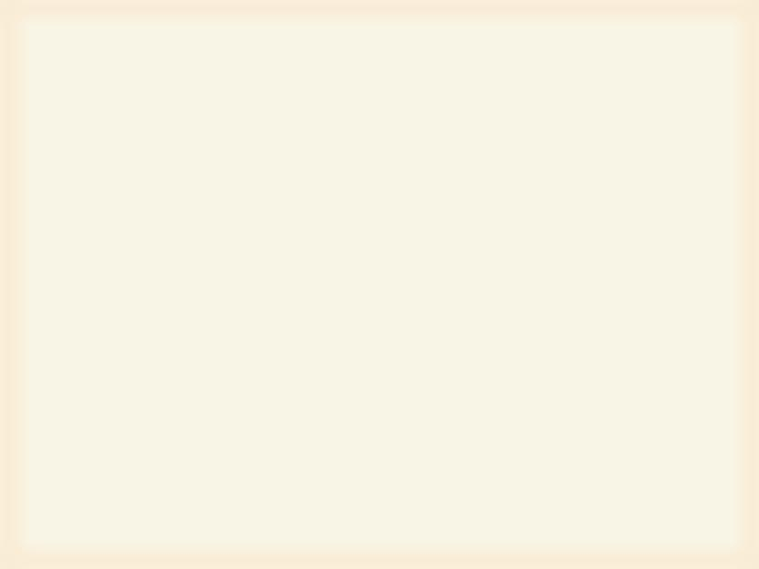

Revolution Software Developers
Sri Lanka Institute of Information Technology
Kalupahana SIG
IT11028888
Perera AAGAK
IT11031758
Kirinda GLM
IT11032816
Piumika WMS
IT11034346
Jayarathne RPET
IT11034582
Thilantha BY
IT11035336
Chathuranga AWI
IT11035718

Kurukulasuriya LK
IT11056294

OVERVIEW OF THE SYSTEM
Every vehicle has
1) A log book
2) A maintenance file
3) A daily running chart book

I) Log book has information about all accident repairs, AC repairs, tires, battery charges etc of the vehicle.
It’s a book provided for maintenance by the government for government institution.

II) Maintenance file has all the documents (forms) used in vehicle repairs, insurance etc.
Example:
For repairs there is a “job form” issued by the driver (once he notices this vehicle needs repairs of this sort). Once DGM approves the form, then a separate form is filled with the repairs to be done on the vehicle and sent to the registered garage.
Example:
Once a year all the vehicles insurance is taken on January 1st. if a vehicle is bought in the middle of the year, then the insurance is taken for a small time period until December 31st. and a new insurance begins form January 1st. without an insurance a vehicle is not put on the road.

Revolution Software Developers
Sri Lanka Institute of Information Technology
Kalupahana SIG
IT11028888
Perera AAGAK
IT11031758
Kirinda GLM
IT11032816
Piumika WMS
IT11034346
Jayarathne RPET
IT11034582
Thilantha BY
IT11035336
Chathuranga AWI
IT11035718

Kurukulasuriya LK
IT11056294

III) Daily running chart is available inside the vehicle itself. It has reason on for trip, time left and initial meter reading, time arrived and final meter reading. All are recorded by driver. There can be many drivers for one vehicle. If there is a difference in meter reading, then the previous driver may have gone somewhere without an approval.
There are two copies of vehicle requisition form
i) For security guards – security division has the originals of all requisition forms. [once a vehicle arrives, the security guard comes running with the requisition form to see if the vehicle is approved to leave]
ii) For Transport division (carbon copy)

Current Process
- First fill in a ‘Vehicle Requisition Form’. Send the form to Transport Manager. If the trip is out of Colombo or out station, it is sent to the DGM by pian. DGM approves or rejects and send forms to ‘Vehicle Manager’ or the Transport Manager approves. Then Vehicle Manager allocates a vehicle for the approved form.
- At present to know if approved or not, you must go to the Vehicle Manager and check. If the vehicle is provided to go to the ground floor and Transport division sends the vehicle(driver has the gate pass)
- On leaving the head office, time, date and route are inserted by driver and on returning date and time are inserted by driver. Kilo meter are recorded on the gate pass.

